**Driver Data Analysis**

1. **External table Creation & Data Loading**

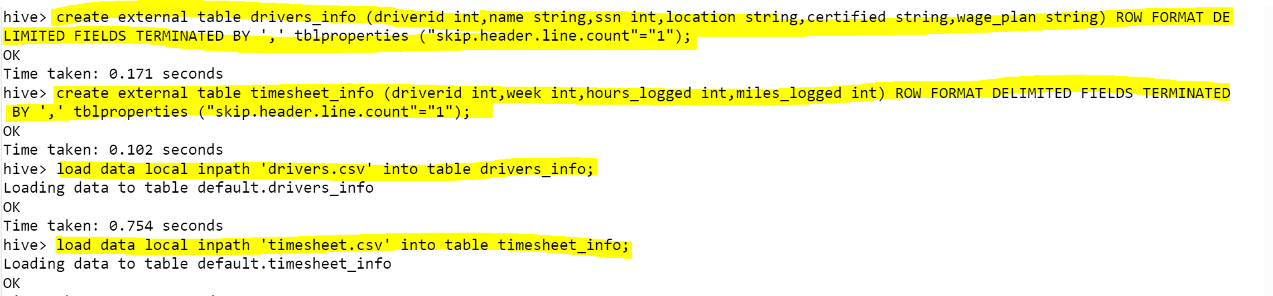

1. **How many total hours and miles logged by each driver?**

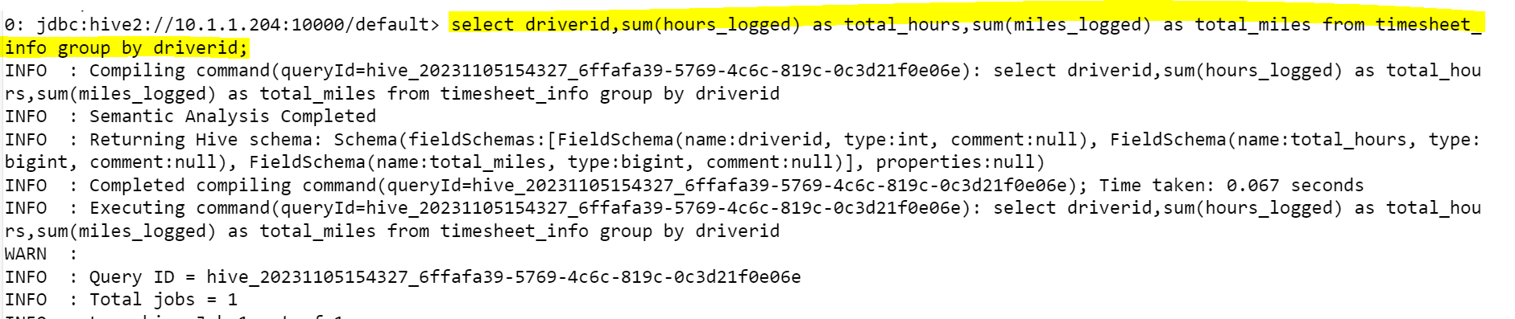

1. **Print the name of the driver in the above query.**

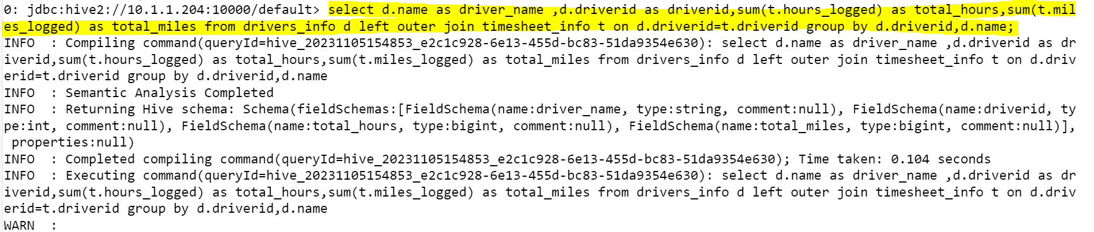

1. **Write the above query output in to hdfs directory.**

 



